Siddhanta Shiromani
Grahaganit adhyaya
Madhyamaadhikare Grahanayanpakramah
(Section I, Chapter 3 : Computation of Planetary Positions)

Verse No | Translations
1-3 | Multiply the number of solar years in an Aeon (4,320,000,000) as said previously with 12 and add to it the months elapsed from the beginning of the lunar year. Multiplying this result by 30 and adding to it the number of elapse lunar days (Tithi) we have the result as solar days (or Mixed days). Multiplying this number of solar days (mixed days) with the number of intercalary months (1,593,300,000) in an Aeon and dividing the product by the number of true solar days (1,555,200,000,000) in an Aeon we will have the result as the number of elapsed intercalary months (ignore the fractional part). Multiplying this amount of intercalary months with 30 and adding to the number of solar days (mixed days) we will have the number of desired lunar days. If we multiply this number of lunar days with the number of omitted lunar days or Avama (25,082,550,000) in an Aeon and the product be divided by the number of true lunar days in an Aeon we will have the quotient (ignoring the fractional part) as number of elapsed omitted lunar days (Gata Avama). If we subtract this number of elapsed omitted lunar days from the previously-said desired lunar days we will have the result as the mean civil days of a week or the number of civil days which has elapsed at any given date (Ahargana). Of the previously determined days of the intercalary months (Adhimaasa) and the omitted lunar days (Avama) ignoring the Dandas, we have to only consider the number of months and days respectively.  Bimala Prasada Siddhanta Saraswati’s Note :  The above mentioned method of calculation of Aharganas by Bhaskara follows the rule laid down in the Shri Surya Siddhanta. Except for Bengal, rest of India uses lunar calendar. Using this type of calendar, the method of calculating the number of days that has elapsed from the beginning of an Aeon is called Ahargana Sadhana (calculation of Aharganas). To determine the number of civil days that has elapse from the beginning of an Aeon (Aharganas), we have to know total number of years that has elapsed from the beginning of an Aeon. Multiplying that figure with 360 will yield the number of days that has elapsed from the beginning of an Aeon. But a solar year does not directly correspond to a lunar year. Hence the author has recommended adding the number of elapsed lunar days from the beginning of the lunar year to the number of solar days. For this reason we have denoted the sum of solar and lunar days as “Solar days (Mixed days)”. If we convert these solar days into lunar days we have to add the number of intercalary months to it. Hence we have to also determine the number of intercalary months proportionately. If in an Aeon the number of solar days corresponds to the number of intercalary months then how many intercalary month would be there in the number of elapsed solar days in an Aeon? As because we have added the number of elapsed lunar days from the beginning of the lunar year, we can ignore the fractional part of the number of intercalary months thus determined.  If we find out the number of elapsed lunar days from the beginning of an Aeon, we have to determine the number of civil days. For this we require some calculation, like: if the number of lunar days corresponds to the number of omitted lunar days in an Aeon, then how many omitted lunar days there will be for the elapsed number of lunar days? The difference of civil and lunar days gives us the number of omitted lunar days. If we subtract the number of omitted lunar days from the totallunar days we have the total number of civil days. As the civil days are calculated from sunrise, we can safely ignore the fractional Dandas of the omitted lunar days. Below we illustrate this calculation with the help of an example.  [This note is continued in the next page]

Verse No | Translations
Example :
Calculating the Ahargana of the first day of Saka Era 1823. According to the Verse 28 of Chapter 1 of this book, from the beginning of the present Kalpa (Aeon) to the beginning of the Saka Era (78 AD) 1,972,947,179 years have elapsed. To this if we add 1823 for the present era, we have 1,972,949,002 solar years. Multiplying the number of years by 12 we have 23,675,388,024 solar months. Adding the number of months elapsed from the beginning of lunar year (i.e. 0) and multiplying the sum with 30 we have 710,261,640,720 solar (mixed) days. To this if we add 25 lunar days that have elapsed, we have 710,261,640,745 solar (mixed) days. From the beginning of this year, the possibility of a difference in the number of elapsed solar and lunar months does not exist, as it is being said that, that there occurs a difference between solar and lunar months after 32 solar months and 16 Dandas have elapsed. So within a year there are same numbers of lunar months as there are solar months. Also, as a difference crops up between solar and lunar days after every 63 days, the difference between solar and lunar months does not exist. As in a month there cannot be 63 lunar days, the number of solar and lunar days are same in a month.

If we multiply the number of solar (mixed) days in an Aeon (710,261,640,745) with the number of intercalary months in an Aeon (1,593,300,000) we have a result 1,131,659,872,199,008,500,000. if we divide this by the number of true solar days (1,555,200,000,000) in an Aeon we have the number of intercalary months (i.e. the quotient) as 727,661,954 and 1,338,208,500,000 as the remainder of this division. Multiplying the number of intercalary months by 30 we have 21,829,858,620 as the intercalary days. If we add this to the number of solar (mixed) days we have the total number of lunar days as 732,091,499,365. if we multiply this number of lunar days with the number of omitted lunar days (25,082,550,000) we have a product of 18,362,721,637,397,580,750,000. Dividing this with the number of true lunar days (1,602,999,000,000) in an Aeon we have the quotient 11,455,229,627 as omitted lunar days (Avamadina) and 546,207,750,000 as the remainder (Avamasesha). Subtracting the number of omitted lunar days from the number of lunar days (732,091,499,365) we have 720,636,269,738 as the result. This is the mean Ahargana (number of civil days which has elapsed from the beginning of the present Kalpa till Saka Era 1823) at Lanka at the sunrise of Sunday, on the first day of Saka Era 1823.

4 | If we multiply the number of revolutions of a planet in an Aeon with Aharganas and divide that by the number of civil/earth days (1,577,916,450,000) then the quotient will be the mean revolution of that planet during the mean position of the sun at Lanka.
5 | If the remainder (Avamasesha) that we have obtained from the calculation of Aharganas is divided by 131,490,000,000 then we have the result as degrees. If we multiply the number of lunar days with 12, add this product to the degrees thus obtained and subtract this sum from the mean lunar revolution we have the result as mean solar revolution. Similarly if the above sum is added to the mean solar revolution we have mean lunar revolution.  Bimala Prasada Siddhanta Saraswati’s Note :  If the number of lunar days in an Aeon is divided by the number of omitted lunar days in the Aeon we have the quotient as Avamasesha (fractional part of Avamadina). Dividing this quotient with the number of lunar days in an Aeon we have the number of civil days as the quotient. To convert these civil days to lunar days we have to multiply this with the number of lunar days in an Aeon and divide the product with the number of civil days in an Aeon. For each lunar day the difference of sun’s and the moon’s position is 12°. So the total difference of sun and the moon in degrees is :  We can take the denominator of the above fraction as 13149 X 10⁷. The error factor of this will not be more than 5 Anukalas. If to this difference of sun and moon in degrees resulting from the omitted lunar days we multiply 12 then we will have the difference of sun and moon in degrees for the elapsed lunar days. As we know,  Mean Solar Revolution + difference of sun and moon in degrees = Mean Lunar Revolutions  Hence, Mean Solar Revolution = Mean Lunar Revolutions - difference of sun and moon in degrees

Verse No | Translations
6 | If the Avamasesha, which we have ignored while computing the Aharganas divided by 27,110,000,000 we will have the Dhanakalaas of the sun. If we multiply the Dhanakalaas of the sun by 13 and add to it ¹/₃₅th part of this product we will have the Dhanakalaas of the moon.  Bimala Prasada Siddhanta Saraswati’s Note :  For the convenience of the readers Bhaskara has described a few different ways of computing planetary positions. An Avama is the time period between the end of a lunar day (Tithi) and sunrise. Slowly this time period will increase and when two lunar days will end within the same solar day, we will have an omitted lunar day (Tithikshaya). This process is so described as we need to calculate the amount of omitted lunar days in an Aeon when we calculate Aharganas, and this is because Aharganas are the collection of civil days, i.e. the days from one sunrise to the next. But we need also to take into account the Avamasesha in those places where we have to compute the solar and lunar speed when the lunar day ends at night and we have some time before the sun rises in the next day. If we multiply the elapsed lunar days in an Aeon with the number of Avamas in an Aeon and divide the product thus obtained by the total number of lunar days in an Aeon we have Avama. So if the remainder of the division is again divided by the total number of lunar days in an Aeon we will have fractional part of Avama (i.e. Avamasesha), which would be the time between end of a lunar day at night and sunrise of the next day expressed as fractional part of a day. If we multiply this fractional part with the daily motions of sun and the moon then we will have the Dhanakalaas of sun and the moon respectively.  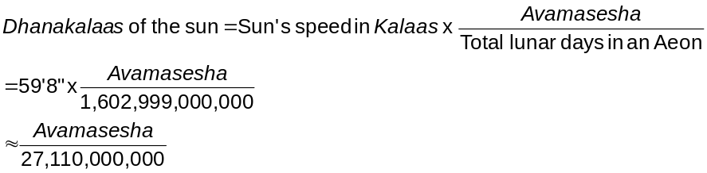  But the daily speed of the moon (790’34”) exceeds that of the sun’s daily speed (59’8”) by  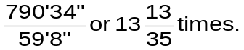  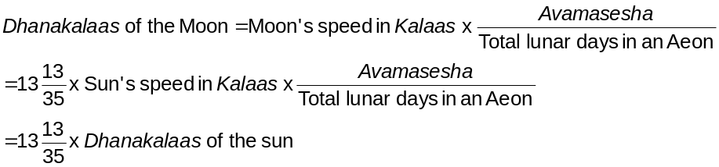Hence we have :

Verse No | Translations
7 | From the beginning of the month of Chaitra the number of elapsed lunar days shows the position of the sun in degrees. Thirteen times of the elapsed lunar days shows the position of the moon in degrees. If the fractional part of intercalary months (Adhimaasasesha) that was ignored during the calculation of the Aharganas be divided by the total number of lunar days in an Aeon we have the result in degrees. If we subtract this from the positions of sun and moon we will have separate remainders which when added separately to the Dhanakalaas of sun and the moon (as said in the 6th Verse) we will have the mean positions of sun and the moon respectively. (However where the sum exceeds 360°, it should be subtracted from 360° and the remainder should be considered).  Bimala Prasada Siddhanta Saraswati’s Note :  If we know the position of the sun (in degrees) and the lunar day we can easily find out the position of the moon (in degrees). The solar year begins when sun enters into Aries. We should know the number of solar days from that point. But we only know lunar days. An intercalary month is the difference of solar and lunar month. If we divide the fractional part of the intercalary month (Adhimaasasesha) by the total number of solar days in an Aeon, we have a fractional part of the Adhimaasa. This is in terms of lunar days. To convert this to solar days we have to multiply it with total number of solar days in an Aeon and divide he product with total number of lunar days in an Aeon. As total number of solar days in an Aeon appears as both numerator and denominator of the fraction it cancels each other out. Hence we have,  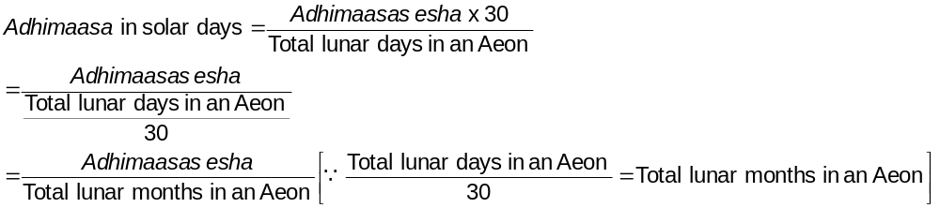  If we subtract this from the positions of sun and moon we have their mean positions. To find out their rising and setting position we have to add to this the Dhanakalaas of sun and moon (as is being said in Verse 6).
8-9 | If we multiply the Aharganas with the own civil days of a planet and divide the product by 131,493,037,500 we will have a result in degrees, which when subtracted from the mean position of the sun yield the mean position of the planet. The scholars regard this as the computation of mean planetary position.  Bimala Prasada Siddhanta Saraswati’s Note :  Actually it is calculated as follows (all figures pertain to an Aeon) :  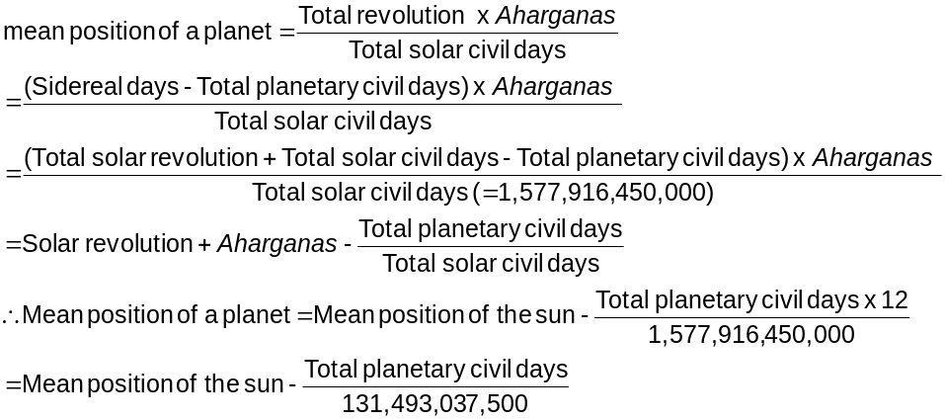

Verse No | Translations
10-11 | If the Adhimaasa (intercalary months), Avama (omitted lunar days) and lunar months are rightly added or subtracted we have the mean position of the planet. As they are derived proportionately from the solar Aharganas (total number of civil days from the beginning of the present Aeon), if they are rightly added or subtracted they will yeild the mean position of the planet.
12 | Determining the mean of the sum of two planetary revolutions and difference of two planets, if we take the half of the sum of the two means we will have the mean position of the faster moving planets and if we take the half of the difference of two means we will have the mean position of the slower moving planet.  Bimala Prasada Siddhanta Saraswati’s Note :  We know that :  Now,  Sum of revolutions = revolution of faster planet + revolution of slower planet (ii)  And,  Adding equation (ii) and (iii) we have,  2 x revolution of faster planet = Sum of revolutions + Difference of revolutions  or, revolution of faster planet = (Sum of revolutions + Difference of revolutions) ÷ 2 (iv)  And subtracting equation (iii) from (ii) we have,  2 x revolution of slower planet = Sum of revolutions - Difference of revolutions  or, revolution of slower planet = (Sum of revolutions - Difference of revolutions) ÷ 2 (v)  Now, substituting the value of revolution of Difference of revolutions = revolution of faster planet - revolution of slower planet (iii)faster planet from equation (iv) into equation (i) we can determine the mean position of the faster moving planet. Similarly, substituting the value of revolution of slower planet from equation (v) into equation (i) we can determine the mean position of the slower moving planet.
13 | Subtracting the difference of revolutions of the two planets from the mean position of the faster moving planet we will have the mean position of the slower moving planet. If the same difference of revolutions of the two planets be added to the mean position of the slower moving planet, we will have the mean position of the faster moving planet.  Bimala Prasada Siddhanta Saraswati’s Note :  From equation (i) as given above we come to know about the direct relationship between the revolution of a planet and its mean position. Hence we can make use of the sum and difference of revolutions of the planets in equation (i). Again we know that,  Difference of revolutions = Revolution of faster planet - revolution of slower planet (iii)  By using transposition to equation (iii) we have,  Revolution of slower planet = Revolution of faster planet - Difference of revolutions  Again using transposition to equation (iii) we have,  Revolution of faster planet = Revolution of slower planet + Difference of revolutions

Verse No | Translations
14 | If we subtract the commutation from the apex of fastest motion we have the mean position of the planet. If we add mean anomaly from the apex of the slowest motion we have the mean position of the planet. If we multiply Siddha mean position with number of Sadhya revolution and divide it with the total Siddha revolutions we have the Sadhya mean position.  Bimala Prasada Siddhanta Saraswati’s Note :  From equation (i) as given above we have,  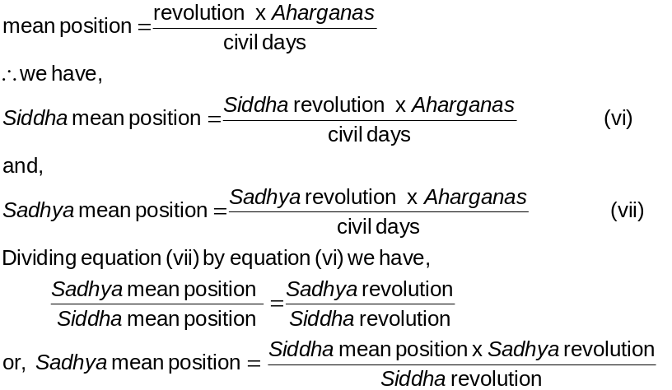
15 | The number of revolutions of the mean position of a planet is called a Chakra and the revolution of the zodiac in degrees is called Agra. If the mean position of a planet is being multiplied by the total number of civil days in an Aeon and this product is divided by the number of its revolution in a Aeon, we have the quotient as Aharganas. Aharganas can also be determined using the difference of Agra and Chakra or just only the Chakra or the sum of the 2 Agras and the rule of Kuttaka (which would be described subsequently).  Bimala Prasada Siddhanta Saraswati’s Note :  We know that :  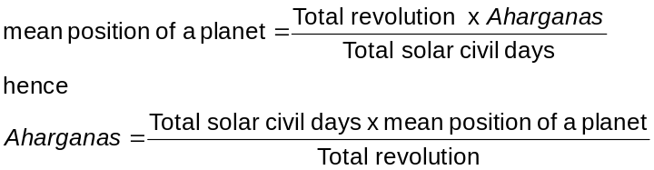

Verse No | Translations
16-17 | When we multiply Aharganas with the number of omitted lunar days (Avama) in an Aeon and then this product be divided by the total number of civil days in an Aeon we would have the number of elapsed Avamas. If we add this number of elapsed Avamas to the Aharganas we could determine the number of lunar days (Tithigana). If we multiply the Tithiganas with the total number of intercalary months in an Aeon and divide that product with the total number of lunar days in an Aeon, we will get the total number of intercalary months that has elapsed. Multiplying the number of intercalary months by 30 and subtract this product from Tithiganas we will have the remainder as the number of solar days. Dividing the solar days by 30 we will have the number of solar months in an Aeon. Dividing the number of solar months by 12 we will have the number of solar years in an Aeon.  Bimala Prasada Siddhanta Saraswati’s Note :  We know from the calculation of Aharganas that,  Solar (mixed) days = (elapsed solar year x 12 + lunar months elapsed from beginning of the year) X30 + elapsed lunar days  Hence it follows from this verse for normal motion :  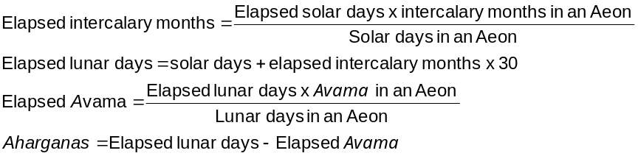  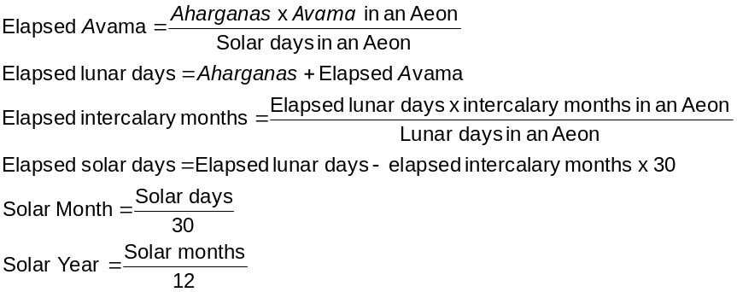And for retrograde motion :
18 | If we calculate the Aharganas from the beginning of the Kali Yuga (Iron Age) we will have the days begining from Friday. Using this to the mean planet that is obtained, if we add their own constants for each planet we will get their individual mean positions.
19-20 | During this time the seconds (Vikalaas) in the positions of the planets, the sun and the moon that remained for their Chakra to be completed were 3370 for Mars, 9931 for Mercury, 1944 for Jupiter, 4666 for Venus, 4406 for Saturn, 1016064 for Sun (zenith), 844214 for the apex of slowest motion (Mandocca) for Moon, 744422 for node (Pata) of the Moon.  Bimala Prasada Siddhanta Saraswati’s Note :  At the beginning of the Kali Yuga (Iron age) there was no mean for Sun. The position (in signs, degrees etc) of the other planets and apex of slowest motion and node for the moon is already given in the note. As the other heavenly bodies have slow speeds we need only to calculate them once at the beginning of the Kali Yuga (Iron age).
Hence ends the chapter named Madhyamaadhikare Grahanayanpakramah
of Grahaganita part of Siddhanta Shiromani

This whole section is very confusing and devoid of a logical progression. But this is exactly what Bimala Prasada Siddhanta Saraswati says. It would be better if we check this with Sanskrit translation of the commentary given on this verse.
Saka era + 78 = Present International year; in other words, 1823 + 78 = 1901 AD
Bimala Prasada Siddhanta Saraswati’s note : Golaadhyaya, Madhyagati, Vasana commentary, 10th Verse. Translator’s note : It seems I have made a mistake. This part is only the translation of planetary motion part of Siddhnata Shiromani.
Bimala Prasada Siddhanta Saraswati’s note : More correctly 32 solar months, 15 Dandas, 31 Palas, 28 Kashthaas and 47 Nimeshas
Bimala Prasada Siddhanta Saraswati’s note : At the place where the terrestrial equator cuts the prime meridian
Dhana means excess, so this means and additive constant in minutes (Kalaas) in finding out the position of the sun.
In such case the first lunar day is always omitted. Hence we have an omitted lunar day. But generally speaking Avama = Tithikshaya
That is first month of the year.
Bimala Prasada Siddhanta Saraswati’s note : If we subtract the position of sun from that of the moon we will observe that each lunar day occurs for a difference of 12°. Hence for each lunar day the difference in the position of sun and the moon is 12°. If we consider that a lunar day s equivalent to a solar day, then we will have for each lunar day, the sun moves by 1° and the moon moves by 13°. So we can take the number of elapsed lunar days as the position of the sun in degrees and 13 times the number of elapsed lunar days as the position of moon in degrees. But for accuracy we have to do some correction to this measure.
Bimala Prasada Siddhanta Saraswati’s note : According to Bhaskara if we subtract apex of slowest motion from the position of the planet we have the mean anomaly (Mandakendra). But According to the author of Shri Surya Siddhanta if we subtract the position of the planet from the apex of slowest motion we have the mean anomaly (Mandakendra). The difference between the apex of fastest motion and mean position yields us the commutation or mean anomaly. Depending on the planet this difference is taken either normal (Anuloma) or retrograde (Biloma).
Bimala Prasada Siddhanta Saraswati’s note : Siddha means what is already determined by calculation.
Bimala Prasada Siddhanta Saraswati’s note : Sadhya means what is to be determined by calculation.

